

Newsletter -- September 2009

😐 Brothers. It's been some time since the 😐 Alumni Association of Central Florida (KSAACF) held our restructuring meeting back in March 2008. Since that meeting, the primary focus of your Executive Committee (EC) has been to facilitate increased brotherhood opportunities by hosting events, which also helps generate more interest and build some momentum for your Association. Here are the current objectives you helped establish for our Association along with updates on our progress and future plans and events.
Objective 1: Hold Alumni Events
1a Hold Quarterly 😐 Happy Hour
Gatherings - The quarterly 😐 happy hour gatherings have been very successful. Attendance is commonly over 30 including spouses and guests. Only concern is..Where are the younger brothers? The EC is asking
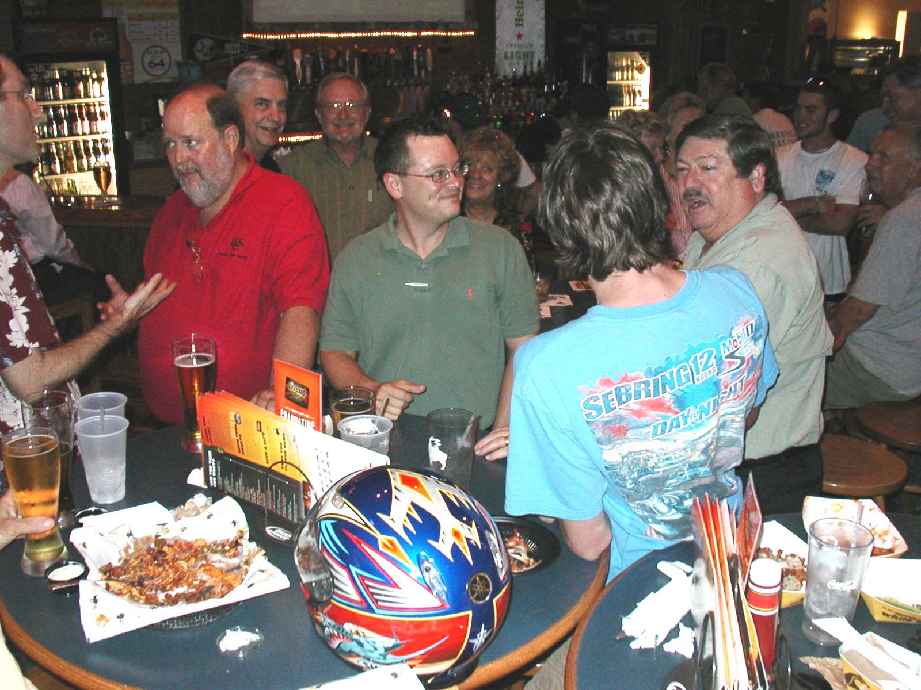

Brothers Tessmer, Howard, Worsley, Calhoun, Hastings, and Lowe to help get more of the younger brothers out. The next happy hour gathering will be in
January 2010. Dates and times of the quarterly gatherings are posted at http://www.ksaacf.org and on Facebook at http://www.facebook.com/group.php?gid=2409383701. See the discussion below under Objective 2: Increase communications.
1b Hold Annual Anniversary Celebrations – Plan on joining your brothers in celebrating the 39th anniversary of the chartering of the ΛΕ Chapter of 😐 at UCF on Saturday, April 17, 2010. The celebration will include our annual golf outing on Saturday morning followed that evening with a business casual dinner. Our first annual golf outing was held in June at Eastwood Golf Club in Orlando. Not surprisingly, it was a
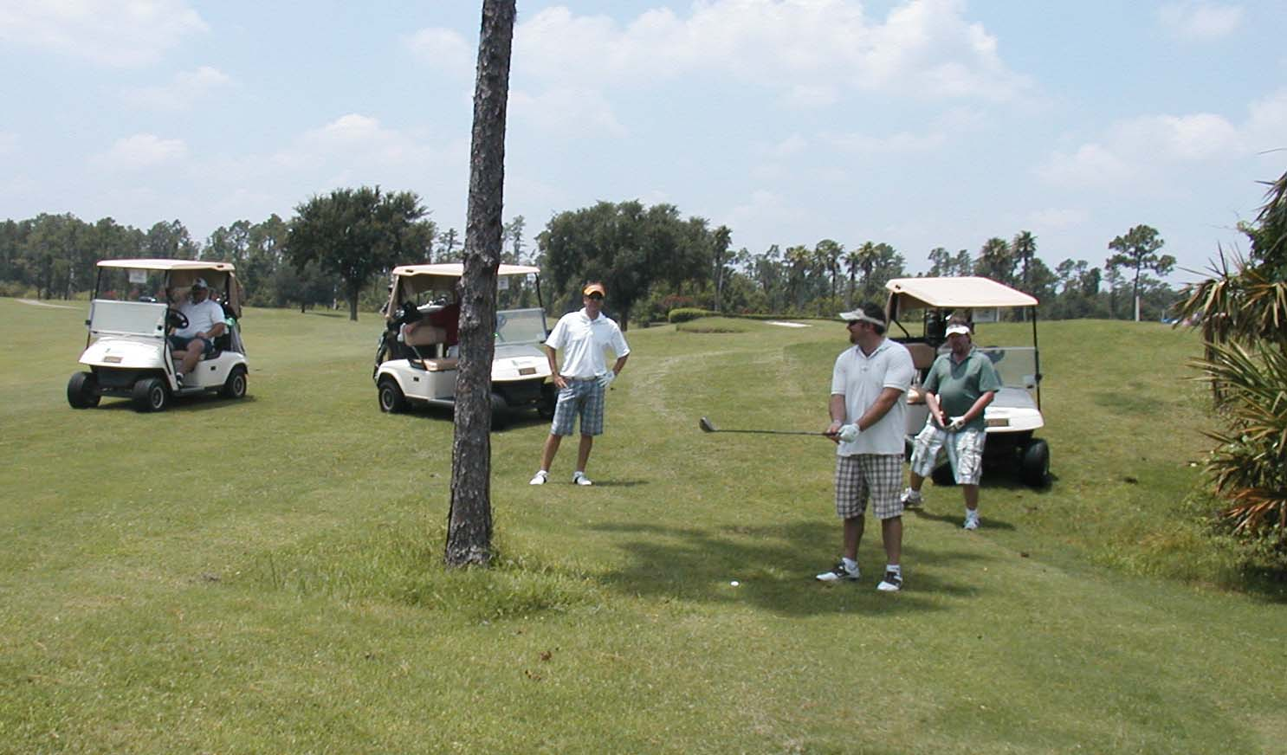

little warm and rather humid, so the annual KSAACF golf outing has been moved up to the spring to coincide with the ΛΕ anniversary celebration. Our expert event planner, Brother Scott Fagan, has again volunteered to plan the Anniversary dinner. Brothers Scott Hastings and Dave Wright will again be making the golfing arrangements.
1.c Hold Annual Tailgates at the Chapter House – Come join us as we begin a new UCF football tradition, a 😐  Homecoming Tailgate at the ΛΕ Chapter House. The active brothers have invited all 😐 alumni to set up our tailgate tents on the front lawn of the house prior to the homecoming game. This year the Knights play Houston on Homecoming Saturday, November 14. Tailgating will start at 8 am and continue up to the noon kickoff. Not only will this enable larger numbers of 😐s to tailgate together as a group at least once a year, but it also will provide an excellent opportunity for alumni brothers to get to know the active brothers better.

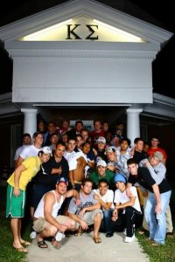

Speaking of gathering at the house prior to football games, a small group of alumni brothers have started another tradition, by meeting at the ΛΕ Chapter House a couple of hours before kickoff. The alumni brothers walk the halls of the chapter house for about an hour, visiting and getting to know the actives and their guests while enjoying a refreshment. The

gathering time is usually three hours before every home football game with the gathering time posted on Facebook at http://www.facebook.com/group.php?gid=2409383701.
Objective 2: Increase communications
2.a Send Periodic E-mails and Make Facebook Postings Announcing Upcoming 😐 Alumni Events - In addition to our website, the KSAACF uses Google Groups to communicate the latest information about future alumni events and developments concerning the Association. Please sign up at http://www.ksaacf.org/groups.html. Event announcements are posted on Facebook at http://www.facebook.com/group.php?gid=2409383701. Brother Lloyd Woosley also posts event announcements on Facebook, so just add him as a friend on your Facebook account. Not into Facebook? He also sends out e-mails announcements, so just ask him to add you to his 😐 e-mail distribution list.
2.b Publish Periodic Newsletters - This issue has been slow in coming, but the EC wanted to demonstrate progress towards meeting our goals. It is anticipated that alumni newsletters will be published semi-annually. Contributions are welcome, so send your announcements and articles to Brother Woosley at lhwoosley@yahoo.com.
2.c Keep the KSAACF Web Site Current - Brother Richard Patch is not only an excellent Treasurer for your Association but he also is an accomplished webmaster. Richard is keeping your web site current by posting upcoming KSAACF events on our calendar, posting photos from past events, and providing timely announcements.
2.d Establish an Undergraduate Relations Coordinator - Kevan Stone is serving as KSAACF Undergraduate Relations Coordinator in addition to serving as  ΛΕ Assistant Alumni Advisor and as a VP for your Association.
2.e Establish a Younger Brothers Relations Coordinator - The EC is recruiting a volunteer.
2.f Establish a Chapter Historian - The EC is recruiting a volunteer.

Objective 3: Support Charitable Causes

3.a Establish a "Brothers in Need Fund" - The KSAACF has established the “Brothers in Need Fund” to assist 😐s in need of a helping hand. To date, over $1,800 has been donated to assist Charter Brother Richard “Jeff” Junkins, who suffered a stroke while living in Costa Rica in 2000. Brother Junkins now relies on public assistance for his care at an extended care facility in Orlando. The money donated to the Fund on his behalf are being used to provide Brother Junkins with much needed dental care that would not be provided by the State.
3.b Support Undergraduate Charitable Causes - The KSAACF is supporting charitable fund raising efforts by the ΛΕ actives on behalf of the Brian Dornbusch Memorial Scholarship Fund. They have raised over $3,000 to-date. As many of you know, Brother Dornbusch was only 33 when he passed away last year after developing a blood clot during cancer treatment. He was very involved with 😐 and the ΛΕ Chapter. In memory of Brother Dornbusch, an endowed scholarship has been created through the UCF Foundation. Your Association was a Platinum $500 Sponsor for Brian Dornbusch Memorial 5k Run and Walk held by ΛΕ on September 26.

3.c Make it Easy to Make Donations to Charitable Causes Supported by the Association - Making a donation to the Brothers in Need Fund on behalf of a named brother or to the Brian Dornbusch Memorial Scholarship Fund just got easier! You can a make donation on-line at any time using Paypal by going to http://www.ksaacf.org/dues.html. You also can set up a recurring payment of $5 or more per month via Paypal. Part of your monthly payments each year will be cover your $35 annual Association dues with the remaining funds contributed to the Association charitable fund that you designate.
Objective 4. Increase membership

Membership in our Association has varied in recent years as the graph on the next page illustrates. Membership peaked after the re-structuring meeting in 2008. The Association needs your support in order to maintain active alumni chapter status with 😐 and to achieve our Association’s objectives. Annual alumni dues are only $35. There are three methods of payment: (1) mail in a check, (2) charge or pay using e-check via PayPal, or (3) pay Brother Patch directly at the quarterly happy hour gatherings. More information on our dues can be found at http://www.ksaacf.org/dues.html.

Other Noteworthy Happenings and Announcements:

"Around The World" - ATW was started in October 1999 by a small group of ΛΕ brothers that were working up in Philadelphia. Missing Florida, the "Philly" crew each managed to find new jobs in Sarasota. Brother Alan Rosa suggested they take-in a weekend at Epcot, and while the 10 brothers walked “Around The World” enjoy cold refreshments as a way of celebrating their return to Florida. This informal gathering, which is not affiliated with 😐 or the Association (even though 90% of the attendees are from ΛΕ), has become a fun tradition. The annual event is usually held in early October to coincide with cooler temperatures, the Food and Wine Festival at Epcot, and an UCF football bye week or away game. Participation has consistently grown ranging from the initial 10 to about 65 participants in 2008. ATW weekend includes a golf outing on Friday morning and an informal dinner that evening. Friends, family, and brothers that may not be able to participate in Saturday's event at Epcot are invited to join them for golf and/or dinner on Friday. Hotel arrangements are available for out-of-town visitors.

This year ATW is being held during October 9-10 (deadline for the special hotel rate has passed):

Friday, 10am - Golf at Eagle Creek
Friday, 6:30pm - Dinner at Hooters at Lake Buena Vista

Saturday, 10:30am - Meet in front of the Epcot Ball for a group photo and then off to the first country, Canada.

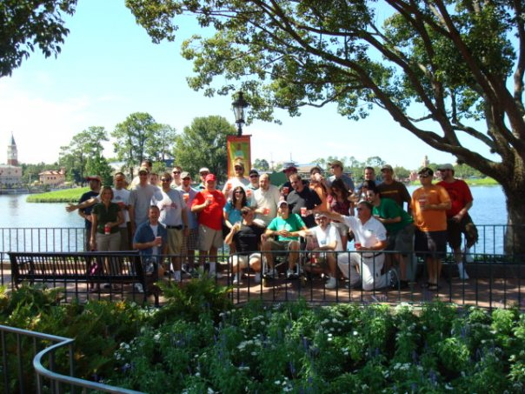

More information about the annual ATW event is posted on Facebook at http://www.facebook.com/group.php?gid=42137179795.

Contact your EC:

If you have any comments about the KSAACF, it’s objectives, or planned activities, please contact any of the EC Members:

President, Lloyd Woosley lhwoosley@yahoo.com, 703-350-8797
1st Vice-President, Kevan Stone
kpstone@gmail.com
2nd Vice President, Dave Wright
carlw@southernpan.com

Treasurer, Richard Patch

kappasig@cfl.rr.com

Secretary, Jim Van Horn
jvanhorn2@earthlink.net
-----------------------------------------------
Please send contributions to the KSAACF newsletter and any announcements to Lloyd Woosley at lhwoosley@yahoo.com.

