Kappa Sigma Alumni Association of Central Florida

AlumNews Newsletter
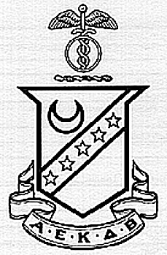
1400 | 1869
Volume 8 Issue 1 Winter 2000
What’s news

Chapter Soars!
This year has been a very exciting one around the chapter house. The most recent events of note include Rush and the chapter’s growth. With 103 brothers, we are currently the largest fraternity on campus! This is a most worthy accomplishment and the undergrads are to be congratulated for all of there hard work in getting the right guys in there to make this thing work. Add to this the 40+ pledges that the guys earned in Fall Rush, and we are talking prime time, baby!
So what else could we possibly expect from these guys? How would a clean sweep of the annual Greek Week activities! Paired with Delta Delta Delta and Pi Kappa Phi, the group took 1st place in 4 of the 5 events. This was an unprecedented victory to say the least.

Spring Weekend
Once again the time for drinks, bagels, and Midnight Basketball at 3AM is rapidly approaching.
When it was all over, you couldn't help but think, "Once a year just isn't enough..." Rory Sanchez
We hope to see a huge turn out for this year’s festivities. Stay tuned for updates and information!

Anniversary 2001
This year, the Anniversary day celebration is going to be a celebration to be remembered. This celebration will mark the 30th anniversary of the chapter. This is a great tribute to the quality of men who started the chapter and who have maintained it ever since. Alumni from across the land are planning to attend and there are plenty of suprises in store.
The event is in its final stages so stay tuned for more information.

TFounders Day
his year, the Founder’s Day banquet was held at the chapter house on campus. It was a new idea to have an informal kind of rap-session that went over really well. It also gave the group an opportunity to meet together at the house. The current brothers and alumni who attended feasted on a tasty meal catered by Woody’s BBQ in Oviedo.
Many stories and new ideas were exchanged. The undergrads spoke on the current status of the chapter, and it was very positive. They also wished to express many thanks to alumni brother Dave McIntosh for his assistance with the recent challenges that faced the chapter.

A Letter from the President
Brothers,
This year is shaping up to be another terrific year. With the Super Bowl and Alumni Weekend behind us, Orlando Predators, Alumni dinners, and a quick 9-hole golf game in our midst, and UCF Football, Homecoming, and Founders' Day on the horizon, it's a great time to be involved in the Kappa Sigma Alumni Association of Central Florida.
I would like to thank those members who have paid their 1999 Alumni Dues:

Eric Fetter
Brian Forgas
Don Kratzenberg
Kevin McNamara
Chuck Moffat
Richard Patch
Mike Ramsey
Phil Townsend

Jeff Waddell
Matt Wattles

I would also like to send out a special thanks to the following members who have continuously supported the Alumni Association in recent years (as far back as our records go):

Six years of support:
- Kevin McNamara (1994 – 1999)
- Chuck Moffat (1994 – 1999)

Five years of support:
- David “Rusty” Beavers (1994 – 1998)
- John Voelpel III (1994 – 1998)
- Lloyd Woosley (1994 – 1998)
- John Slade (1994 – 1998)

Four years of support:
- Brian Cole (1995 – 1998)
- Paul Gamble (1994, 1996 – 1998)
- Ed Knight (1994 – 1997)
- Rick Smiley(1994, 1995, 1997, 1998)
- Jim Van Horn III (1994, 1996 – 1998)
Three years of support:
- Hank Costello (1994, 1997, 1998)
- Tim Dolan (1994 – 1996)
- Greg Hadaller (1994, 1997, 1998)
- Dave McIntosh (1994, 1996, 1997)
- Ray Miller (1996 – 1998)
- Ben Peterson (1994, 1995, 1997)
- Roy “Hunter” Potts (1994, 1996, 1998)
- Mark Ricci (1994, 1996, 1997)
- Rory Sanchez (1994, 1997, 1998)

Your support does not go unnoticed. Your contributions of $30 have supported our Alumni Chapter National Dues, editions of AlumNews, updated Alumni Directories, support of the Lambda Epsilon Chapter House, and Alumni Association sponsored activities. We truly appreciate your donations. Thank you!

A.E.K.D.B.

Richard Patch, President
Kappa Sigma Alumni Association
P.O. Box 4022
Winter Park, FL 32792

AEC Officers

President, Richard Patch
VP, Bryan Farris
2nd VP, Matt Wattles
Secretary, Mike Ramsey
Treasurer, Jeff Waddell

UCF Football Season Wrapup
The UCF football team, an NCAA Division I-A independent, won 7 of 11 games in 2000, primarily behind the play of freshman quarterback Ryan Schneider. The highlight of the season was a 40-38 whipping over the University of Alabama. This was a “we have arrived” game that UCF has been chasing for last few seasons. In another opportunity in the last game of the season, UCF played then ranked #7 Virginia Tech in the Citrus Bowl. Even though we came out on the low side, if you missed this one you missed on heck of a good time.

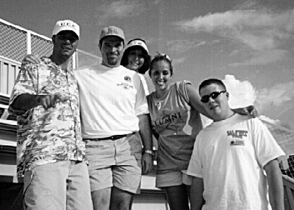
At the Georgia Tech game
Here is the current 2001 schedule:
Sept. 1 at Clemson x:00 p.m.
Sept. 8 at Syracuse x:00 p.m.
Sept. 15 Louisiana-Lafayette x:00 p.m.
Sept. 22 at Tulane x:00 p.m.
Sept. 29 at Virginia Tech x:00 p.m.
Oct. 6 UAB x:00 p.m.
Oct. 13 Liberty x:00 p.m.
Oct. 20 Louisiana-Monroe x:00 p.m.
Oct. 27 at Utah State x:00 p.m.
Nov. 3 Akron x:00 p.m.
Nov. 10 Kent x:00 p.m.

Alumni Listserv
To subscribe to the Listserv, send an email to listcaster@agtech.net. In the body of the message, type SUBSCRIBE <listname>, where listname is KSAACF-AO: for announcements only, KSAACF-GL: for general discussions, and KSAACF-EC: for alumni executive committee discussions.
Monthly Dinner Event
What began as good thing has become a lasting tradition. On the first Tuesday night of every month, come out and join your alumni brothers. We occasionally change the location to keep it interesting, so please give a call or get on the Listserv to get the latest.

Alumni Brother Recognized
Ijust wanted to take a moment to recognize one of our outstanding alumni brothers. Chuck Moffat has been published over the last year or so in The Caduceus for his research on Kappa Sigma brothers and their contributions to the US Space program.
Chuck has really done a great job with this information as it has garnered substantial recognition to our chapter. It is worth tracking down a copy of The Caduceus to see this if you have not already.

Met Daunte
This very moment was more than enough to justify a lifetime membership in the UCF Alumni Association. The second annual “draft party” sponsored by the UCF AA in March, brings players from UCF past and present to “meet the fans.” These brothers were prepared and got several autographs and a chance to meet Daunte Cullpepper, now the starting QB for the Minnesota Vikings.
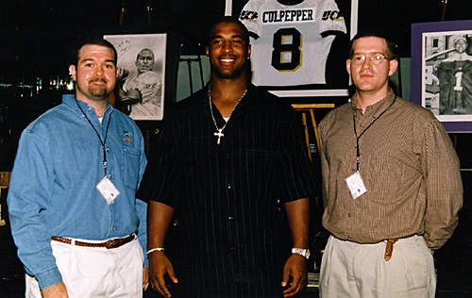
“Brothers” meet Daunte

Pay your dues now. Your help supports the best Chapter in Kappa Sigma!

You can also place a business ad in the AlumNews newsletter. This publication is distributed to over 1200 Kappa Sigma alumni who are eager to patronize another brothers’ business.
Your paid advertisement supports the Alumni Association to defray newsletter costs and enhance communication. Meanwhile, your business taps an abundant customer base. Besides, it’s a great value!

Business Card: $10 Quarter Page: $25 Half Page: $35 Third Page: $30 Full Page: $45

1999 Dues: $30

Name: ________________________ Address: __________________________________
__________________________________
__________________________________
Just fill out and mail with your check made payable to the Alumni Association.

Cut-here and mail!

Kappa Sigma Alumni Association of Central Florida
stamp
here
P.O. Box 4022
Winter Park, FL 32792

